Aaron Banson

Prof. Bama

Advanced Programming in Java

December 18, 2020

Lab 13

User:

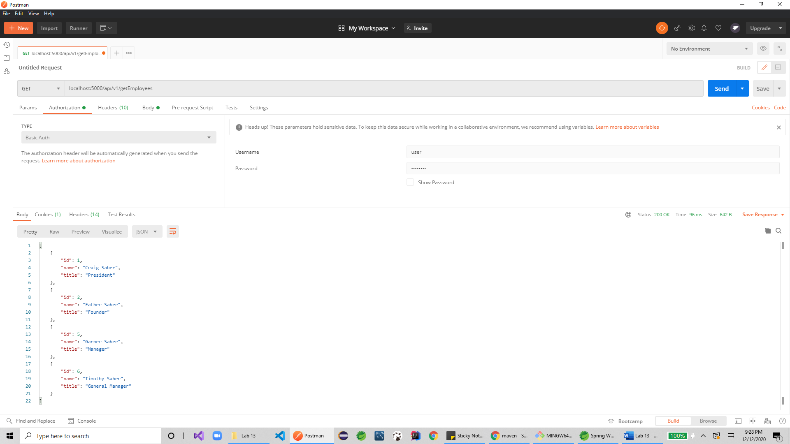

Admin:

